LOYOLA JES UIT SECONDARY SCHOOL
2026 JUNIOR CERTIFICATE MOCK EXAMINATION
GEOGRAPHY
(100 marks)

Subject Number: J073
Time Allowed: 2h 30 min

Date:

Instructions
- This paper contains 13 pages. Please check.
- This paper has three sections: A, B and C
- Follow instructions for each section carefully.
- Write your ID Number in the spaces provided on all the pages of this paper before you start answering the questions.
- In the table provided on this page, tick against the question number you have answered.
- Hand in your question paper to the invigilator when time is called to stop writing.
Question number | Tick if answered | Do not write in these columns
1-20
21
22
23
24
25
26

SECTION A: (20 MARK)
Answer all questions in this section by circling the correct answer.
Each question carries 1 mark.

1. Which of the following is the characteristic of the large scale maps?
- Have smaller denominator
- Shows few details
- Represent a large area
- Have large denominators
2. For how long will the earth take to rotate 120 degrees, if it completes its rotation of 360 degrees in 24 hours?
A. 8 hours
B. 12 hours
C. 3 hours
D. 6 hours
3. On which date is the summer solstice experienced in the Southern Hemisphere experiences?
A. 21st March
B. 21st June
C. 23rd September
D. 22nd December
4. How does the wind vane show the direction of wind?
A. the arrow points to the direction where wind is going
B. the arrow stops turning when wind is slow
C. the arrow rotates faster when there is strong wind
D. the arrow points to the direction where wind is originating
5. Which of the following planets has the ability to support life?
A. Mercury
B. Jupiter
C. Mars
D. Earth
6. Which of the following terms refers to the combined loss of water vapor from vegetation, land and water?
A. evaporation
B. transpiration
C. capillary action
D. evapo-transpiration
Table 1 below shows minimum and maximum temperatures for weather station X and Y, on a particular day. Use it to answer questions 7 and 8.
Table 1
Station | Max. temp (0º) | Min.temp. (0º)
X | 34 | 18
Y | 26 | 12

7. What is the mean temperature for the station X?
A. 26^{O}
B. 20^{O}
C. 52^{O}
D. 18^{O}
8. What is the location of station X?
A. Polar regions
B. Desert region
C. Temperate region
D. High altitude area
9. Which of the following forms of transport is most convenient for transporting light valued goods over long distances?
A. Road
B. Air
C. Rail
D. Water
10. Which of the following will occur to air pressure when vapor in the air increases?
A. air pressure increases
B. wind speed increases
C. air pressure decreases
D. wind speed decreases
11. Which of the following is a physical factor promoting the development of tourism industry in Malawi?
A. Food
B. Culture
C. Beautiful scenery
D. Low cost of living
12. On a map relief can be expressed using various shades of colours called -------------
A. contours
B. Hachures
C. Layer tinting
D.Hill shading
13. Daily rising and falling of tides is an effect of ____________

- Rotation of the earth
- Revolution of the earth
- Earths spherical shape
- Ship visibility
14. Which of the following is the process which resulted to the formation of lake Malawi?
A. Crustal warping
B. Volcanism
C. Meandering
D. Faulting
15. In which months of the year is the hot wet season experienced in Malawi?
A. May to July
B. March to June
C. November to April
D. August to November
16. Why is International Date Line regarded as a great circle?
A. it runs from North to South Pole
B. it divides the earth into two equal parts
C. it has equal length with the equator
D. it is longer than the Arctic Circle
17. Rivers that develop on alternate outcrops of hard and soft rock with tributaries in rectangular drainage pattern are described as ________________.
A. Dendritic
B. Radial
C. Trellis
D. Intermittent
18. A captain of the ship observed that the longitude of his ship was 75ºW and the time in London was 11:00 hours. What will be the time in the ship?
A. 05:00 hours
B. 06:00 hours
C. 15:00 hours
D. 16:00hours
19. Which of the following is an example of dwarf planets?
A. Earth
B. Mars
C. Jupiter
D. Pluto
20. Which of the following is the correct term given to lines joining places of equal temperatures on a map?
A. Isotherms
B. Contours
C. Isobars
D. Isohels

SECTION B (50 marks)
Answer all questions in this section in the spaces provided.
Figure 1 is a map of Mponela.Use it to answer questions that follow:

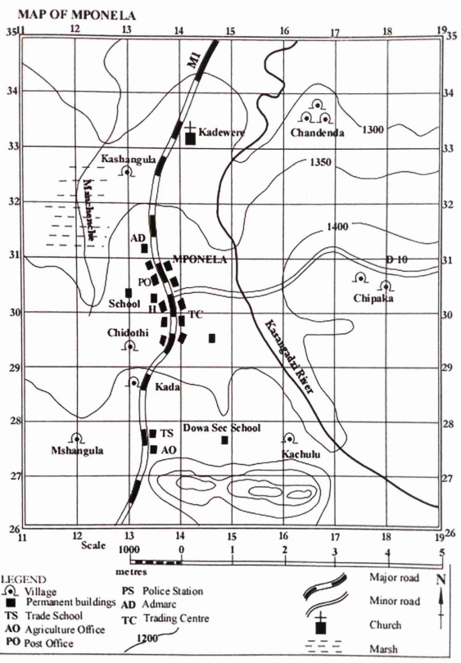

21. a (i) What is the four-figure grid reference of Chandenda village?
______________________________________________________________(1mark)
(ii). Find the six figure grid reference of Dowa Secondary School.
_______________________________________________________________(2marks)
b. Measure the distance of M1 road from Northing 26 to the junction with D10 road. Present your answer to the nearest kilometer.
______________________________________________________________________(3marks)
c. Mention any two settlement patterns shown on the map.
____________________________________________________________________________________________________________________________________________________(2marks)
d. (i). In which direction is Kasangadzi River flowing?
_______________________________________________________________________(1mark)
(ii). Calculate the bearing of Mshangula village from Kawere church.
______________________________________________________________________(3marks)
e. State any two land uses shown on the map.
____________________________________________________________________________________________________________________________________________________(2marks)
f. Calculate the actual area of the land shown on the map to the east of Easting 16.
(6marks)

22. a. Define the term “solar system”.
_____________________________________________________________________________________________________________________________________________________(1mark)
b. Name any example of the dwarf planets.
_______________________________________________________________________(1mark)
c. Describe how the following factors disturb the hydrological cycle:
(i). deforestation:
____________________________________________________________________________________________________________________________________________________(2marks)
(ii). climate change:
____________________________________________________________________________________________________________________________________________________(2marks)
d. Explain how the eclipse of the moon proves that the Earth is spherical.
____________________________________________________________________________________________________________________________________________________(2marks)
e. Give the reason for the presence of the following features on a Stevenson’s screen:
(i). louvered sides
____________________________________________________________________________________________________________________________________________________(1mark)
(ii). Double boarded roof
_____________________________________________________________________________________________________________________________________________________(1mark)
23. a. Figure 2 is an illustration of an instrument used to measure weather. Use it to answer the questions that follow:
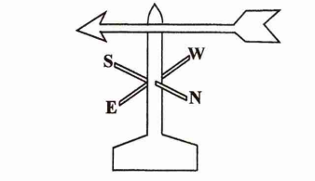s
(i). Name the instrument.
______________________________________________________________________(1mark)
(ii). State the element of weather which is measured by the instrument.
_______________________________________________________________________(1mark)
(iii). Explain how the instrument is used to measure weather.
________________________________________________________________________________________________________________________________________________________________________________________________________________________________________________________(3marks)
b. State any two ways in which air is important in the environment.
___________________________________________________________________________________________________________________________________________________________________(2marks)
C. Explain any one way in which communities living near forests benefit from them.
___________________________________________________________________________________________________________________________________________________________________(2marks)
24. a. (i) State the element of weather which is measured by mercury barometer.
______________________________________________________________________________(1mark)
(ii). Explain how mercury barometer works.
_____________________________________________________________________________________________________________________________________________________________________________________________________________________________________________________________________________________________________________________________________________(3marks)
b. (i) State any two problems brought by Shire river.
________________________________________________________________________________________________________________________________________________________________________________________________________________________________________________________(2marks)
(ii). Explain how convectional rainfall is formed.
_____________________________________________________________________________________________________________________________________________________________________________________________________________________________________________________________________________________________________________________________________________(2marks)
c. Figure 3 is a diagram showing a fishing method. Use it to answer questions that follow.
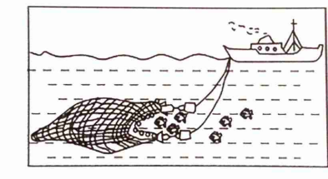
(i). Identify the fishing method.
______________________________________________________________________________(1mark)
(ii). Describe how the method is used in fishing
____________________________________________________________________________________________________________________________________________________________________________________________________________________________________________________________________________________________________________________________________________(2marks)

SECTION C: (30marks)
Answer all questions in an essay form in the spaces provided. Failure to answer the questions in an essay form will lead to automatic loss of 4 marks.
26. a. Explain any four factors that influence the location of industries in Malawi.
_____________________________________________________________________________________________________________________________________________________________________________________________________________________________________________________________________________________________________________________________________________________________________________________________________________________________________________________________________________________________________________________________________________________________________________________________________________________________________________________________________________________________________________________________________________________________________________________________________________________________________________________________________________________________________________________________________________________________________________________________________________________________________________________________________________________________________________________________________________________________________________________________________________________________________________________________________________________________________________________________________________________________________________________________________________________________________________________________________________________________________________________________________________________________________________________________________________________________________________________________________________________________________________________________________________________________________________________________________________________________________________________________________________________________________________________________________________________________________________________________________________________________________________________________________________________________________________________________________________________________________________________________________________________________________________________________________________________________________________________________________________________________________________________________________________________________________________________________________________________________________________________________________________________________________________________________________________________________________________________________________________________________________________________________________________________________________________________________________________________________________________________________________________________________________________________________________________________________________________________________________________________________________________________________________________________________________________________________________________________________________________(9marks)
b. Describe any three effects of natural disasters.
______________________________________________________________________________________________________________________________________________________________________________________________________________________________________________________________________________________________________________________________________________________________________________________________________________________________________________________________________________________________________________________________________________________________________________________________________________________________________________________________________________________________________________________________________________________________________________________________________________________________________________________________________________________________________________________________________________________________________________________________________________________________________________________________________________________________________________________________________________________________________________________________________________________________________________________________________________________________________________________________________________________________________________________________________________________________________________________________________________________________________________________________________________________________________________________________________________________________________________________________________________________________________________________________________________________________________________________________________________________________________________________________________________________________________________________________________________________________________________________________________________________________________________________________________________________________________________________________________________________________________________________________________(6marks)
26. a. Explain any four challenges affecting production and use of hydro-electricity in Malawi.
_____________________________________________________________________________________________________________________________________________________________________________________________________________________________________________________________________________________________________________________________________________________________________________________________________________________________________________________________________________________________________________________________________________________________________________________________________________________________________________________________________________________________________________________________________________________________________________________________________________________________________________________________________________________________________________________________________________________________________________________________________________________________________________________________________________________________________________________________________________________________________________________________________________________________________________________________________________________________________________________________________________________________________________________________________________________________________________________________________________________________________________________________________________________________________________________________________________________________________________________________________________________________________________________________________________________________________________________________________________________________________________________________________________________________________________________________________________________________________________________________________________________________________________________________________________________________________________________________________________________________________________________________________________________________________________________________________________________________________________________________________________________________________________________________________________________________________________________________________________________________________________________________________________________________________________________________________________________________________________________________________________________________________________________________________________________________________________________________________________________________________________________________________________________________________________(9marks)
b. Describe three ways in which landforms are important in the environment.
________________________________________________________________________________________________________________________________________________________________________________________________________________________________________________________________________________________________________________________________________________________________________________________________________________________________________________________________________________________________________________________________________________________________________________________________________________________________________________________________________________________________________________________________________________________________________________________________________________________________________________________________________________________________________________________________________________________________________________________________________________________________________________________________________________________________________________________________________________________________________________________________________________________________________________________________________________________________________________________________________________________________________________________________________________________________________________________________________________________________________________________________________________________________________________________________________________________________________________________________________________________________________________________________________________________________________________________________________________________________________________________________________________________________________________________________________________________________________________________________________________________________________________________________________________________________________________________________________________________________________________________________________________________________________________________________________________________________________________________________________________________________________________________________________________________________________________________________________________________________________________________________________________________________________________________________________________________________________________________________________________________________________________________________________________________________________________________________________________________________________________________________________________________________________________________________________________________________________________________________________________________________________________________________________________________________________________________________________________________________________________________________________________________________________________________________________________________________________________________________________________________________________________________________________________________________________________________________________________________________________________________________(6marks)

END OF QUESTION PAPER

